Gym Management System – Advanced Programming Report



Student Name: Danillo Sampaio.
Programme: Higher Diploma in Science in Computing.
Lecturer Name: Kanza Ali Manzar.
Module Title: Advanced Programming.
Module Code: B8IT150.
1. Introduction
The purpose of this report is to present the design and implementation of a console-based C# application named GymProjectApp, developed as part of the Advanced Programming module. The project demonstrates a two-layer architecture — Business Logic Layer (BLL) and Data Access Layer (DAL) — with integration to a SQLite database. It includes core CRUD operations, sorting and searching algorithms, and applies object-oriented programming principles.
2. Project Overview
2.1 Project Idea
GymProjectApp is a simple gym membership management system. It allows users to:
- Add new members
- Update member details
- Delete members
- View all registered members
The application is designed for console interaction and stores data persistently using SQLite.
2.2 Architecture
The project follows a two-layer architecture:
- BLL (Business Logic Layer): Handles core logic and validation.
- DAL (Data Access Layer): Manages database operations using SQLite.

3. Entities and Class Design
3.1 ER – Diagram
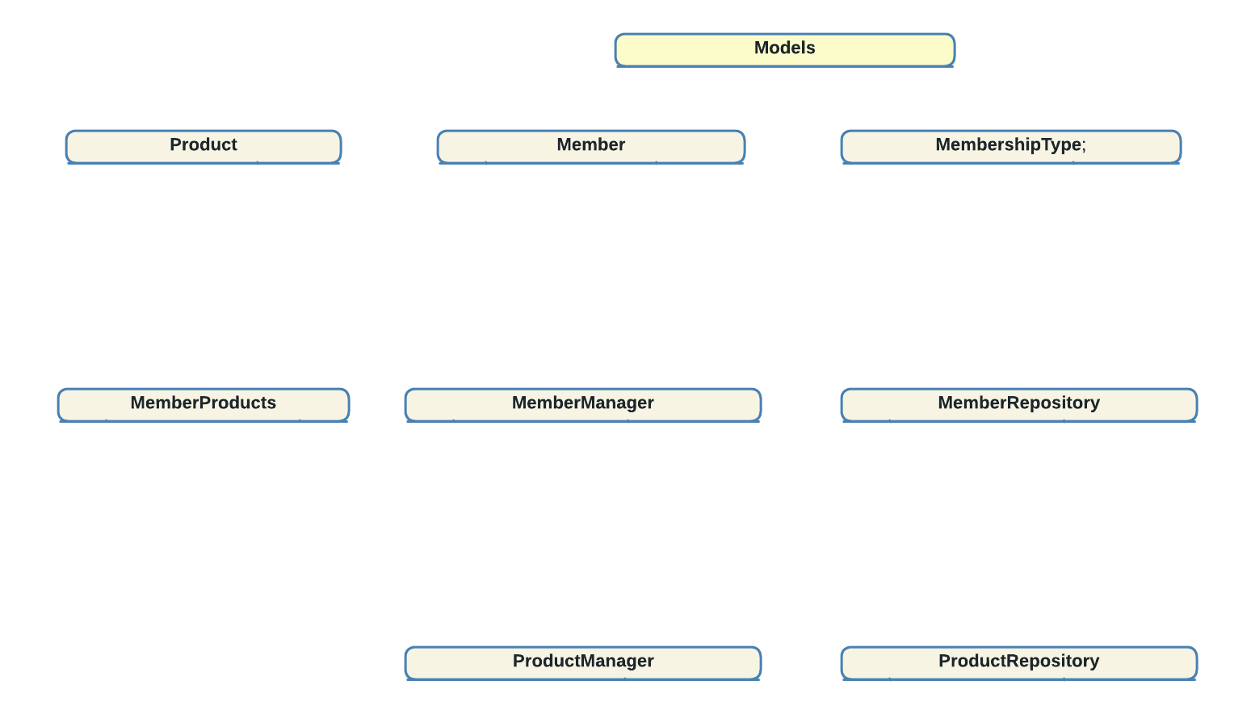

Models
Member
- MemberID : int
- Name : string
- Age : int
- MembershipType : int (FK → MembershipType)
- JoinDate : DateTime

Product
- ProductID : int
- Name : string
- Price : decimal
- Category : string

MembershipType
- MembershipTypeID : int (PK)
- TypeName : string (Monthly, Quarterly, SemiAnnual, Annual)

BLL (Business Logic Layer
MemberManager
- Add(Member) : bool
- Update(Member) : bool
- Delete(int) : bool
- GetAll() : List<Member>
ProductManager
- Add(Product) : bool
- Update(Product) : bool
- Delete(int) : bool
- GetAll() : List<Product>

DAL (Data Access Layer
MemberRepository
- Insert(Member) : void
- Update(Member) : void
- Delete(int) : void
- GetAll() : List<Member>

ProductRepository
- Insert(Product) : void
- Update(Product) : void
- Delete(int) : void
- GetAll() : List<Product>
Relationships
- MemberManager → use MemberRepository
- ProductManager → use ProductRepository
- Program.cs → instance MemberManager and ProductManager
• Member and Product are entities persisted through their respective repositories

3.2 UML Class Diagram
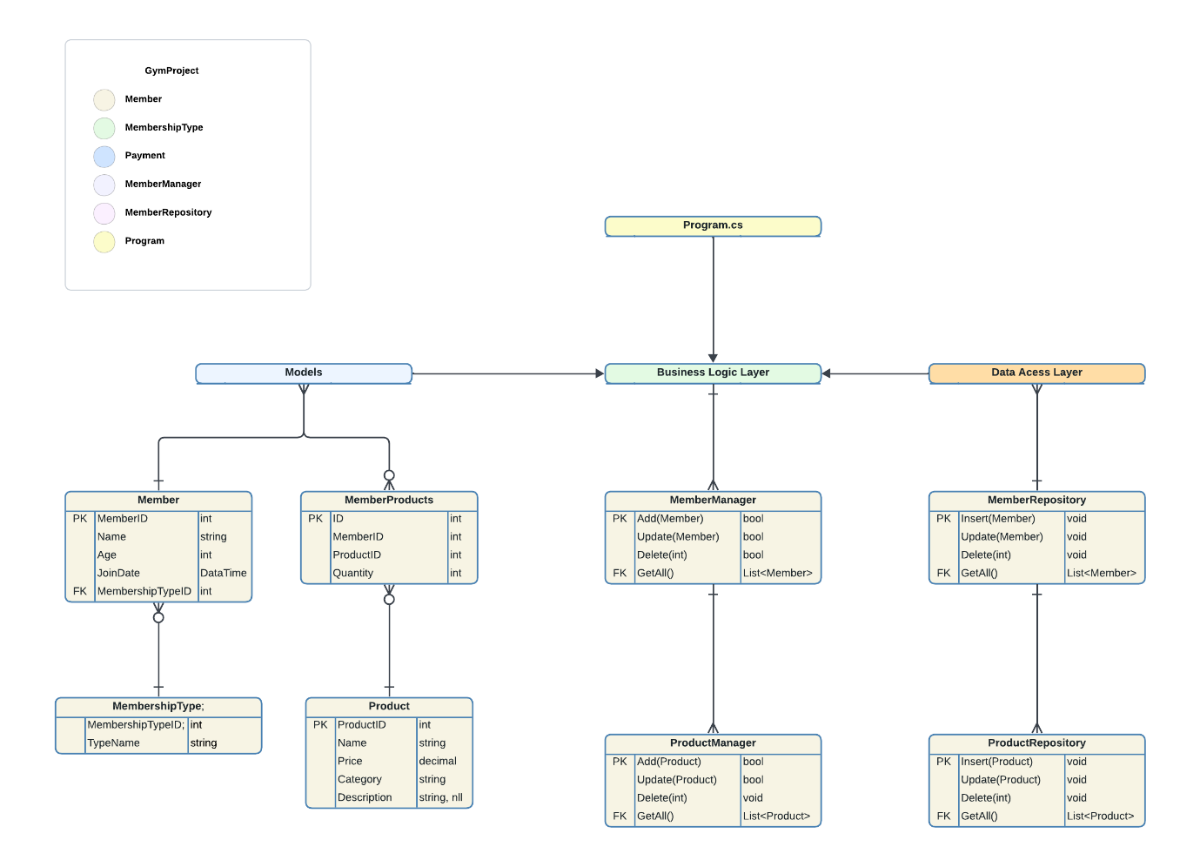

4. Flowchart
The flowchart below illustrates the operational flow of the application:

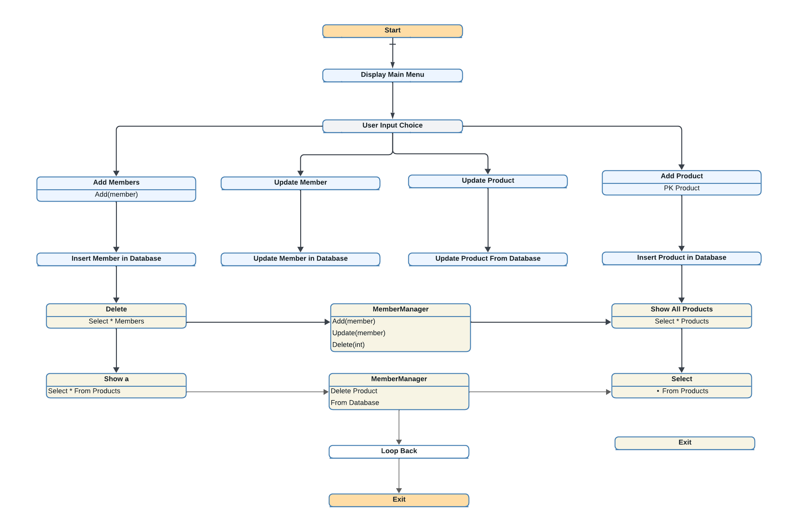

Core Flow Steps
Command | Description
Start | Entry point of the application
Main Menu | Displays options: Add, Update, Delete, Show Members, Show Products
Add Member | Collects input and inserts a new member into the database
Update Member | Updates existing member details
Delete Member | Deletes a member by ID
Show All Members | Displays all members from the database
Add Product | Collects input and inserts a new product into the database
Update Product | Updates existing product details
Delete Product | Deletes a product by ID
Show All Products | Displays all products from the database
Database Operations (SQLite) | General label for all DB interactions (Members and Products)
Insert Operation | Adds new record to SQLite (Member or Product)
Update Operation | Modifies existing record in SQLite (Member or Product)
Delete Operation | Removes record from SQLite (Member or Product)
Select Operation | Retrieves records from SQLite (Member or Product)
End | Terminates the application

Optional Enhancements
Component | Purpose
Input Validation | Ensures correct data types and formats before DB operations
Error Handling | Displays user-friendly messages for invalid input or DB failures
Return to Menu | Allows looping back to Main Menu after each operation
Exit Confirmation | Optional prompt before closing the application

5. Data Structures and Algorithms
5.1 Data Structures
- List: Used to store and manipulate member data in memory.
- String & Int: For basic attributes like name, age, and membership type.

5.2 Algorithms
- Binary Search: Quickly finds a member by name in a sorted list. (Efficient, runs in logarithmic time)
- Bubble Sort: Simple method to arrange members by age or join date. (Less efficient, runs in quadratic time)
The Binary Search is efficient for searching sorted data, while Bubble Sort is easy to implement but slower for large lists

6. OOP Principles Applied
- Encapsulation: The Member and Product classes encapsulate their data and related behavior, ensuring modularity, data protection, and separation of concerns within the system.
- Abstraction: The Business Logic Layer (BLL) abstracts the implementation details of the Data Access Layer (DAL), allowing the user interface to interact with high-level operations without direct access to database logic.
- Polymorphism: Although not currently implemented, the system could be extended through inheritance to support polymorphic behavior — for example, by introducing specialized member types with shared interfaces.
- Interface: Interfaces could be introduced to abstract repository logic, enabling dependency injection, easier testing, and greater flexibility in future upgrades.

7. Efficiency and Disk Usage
The GymProjectApp was designed with simplicity and performance in mind. When it comes to database operations like adding, updating, or deleting records, SQLite handles these tasks efficiently, especially for small datasets, thanks to its internal indexing. While these operations may seem instantaneous, they technically scale in logarithmic time as the database grows.
For searching members by name, the application uses Binary Search on sorted lists, which ensures fast lookups even as the number of records increases. Sorting is handled using Bubble Sort, a straightforward algorithm chosen for its educational value. Although not the most efficient for large datasets, it clearly demonstrates how sorting logic works and is easy to implement and understand.
On the storage side, the SQLite database file (gym.db) is lightweight and self-contained. It requires minimal disk space and offers fast read/write performance, making it ideal for console-based applications like this one. It also simplifies deployment, since the entire database lives in a single file.

8. Conclusion
The GymProjectApp represents a comprehensive application of advanced programming concepts in C#. By combining a layered architecture with clear separation of concerns between the Business Logic Layer and the Data Access Layer, the system achieves both maintainability and scalability. The integration of SQLite ensures persistent data storage, while the implementation of CRUD operations provides a solid foundation for managing members and products effectively.
Beyond its structural design, the project demonstrates practical use of algorithms such as Bubble Sort and Binary Search, reinforcing the importance of efficiency in data handling. Object-oriented principles — including encapsulation, abstraction, and extensibility through polymorphism and interfaces — are consistently applied, showcasing a strong grasp of software engineering fundamentals.
Overall, GymProjectApp not only meets the academic requirements of the Advanced Programming module but also illustrates professional-level practices in system design and implementation. It establishes a reliable framework that can be expanded with features such as graphical interfaces, reporting modules, or network-based functionality, positioning the project as a scalable and future-ready solution.

9. References
- C# Programming Guide – Microsoft Learn. Official documentation covering syntax, classes, OOP, and examples. https://learn.microsoft.com/en-us/dotnet/csharp/
- C# Guide - Microsoft Learn.Tour of C# – Microsoft Learn. Beginner-friendly tutorials and explanations of C# concepts. https://learn.microsoft.com/en-us/dotnet/csharp/tour-of-csharp/
• Programming Concepts in C# – Microsoft Learn. Covers encapsulation, inheritance, polymorphism, and other OOP principles. https://learn.microsoft.com/en-us/dotnet/csharp/programming-guide/concepts/
• Object-Oriented Programming in C# – Microsoft Learn. Explains the four pillars of OOP with examples. https://learn.microsoft.com/en-us/dotnet/csharp/fundamentals/tutorials/oop
• SQLite Official Documentation. Core SQL functions, data types, and usage examples.
https://sqlite.org/docs.html
• Bubble Sort Algorithm – GeeksforGeeks. Simple explanation of Bubble Sort with code samples. https://www.geeksforgeeks.org/dsa/bubble-sort-algorithm/
• Binary Search Algorithm – GeeksforGeeks. Step-by-step explanation of Binary Search with complexity analysis. https://www.geeksforgeeks.org/dsa/binary-search/

